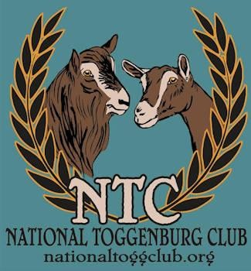
Bell Ringer Award

Awards for lactations beginning in 2024 and completed on or before March 1, 2025.
Award entry deadline: June 1, 2025

Awards are open to Purebred, American, and Recorded Grade Toggenburgs owned by current National Toggenburg Club members with a data collection rating of 75 or greater. All DHIR individual lactation records for submitted entries will be verified for accuracy with the records on file with the ADGA Performance Programs Manager.

The following are the qualifying levels for the National Toggenburg Club Bell Ringer certificates.

Lifetime Award 10,000 pounds or more in lifetime lactation, one time only award
Senior Citizen Award 6 years or older old producing 2,000 pounds milk in 305 days or less

Gold Milk Award 3,500 pounds or more of milk produced in 305 days or less Gold Butterfat Award 120 pounds or more of butterfat produced in 305 days or less Gold Protein Award 90 pounds or more of protein produced in 305 days or less

Silver Milk Award 3,000–3499 pounds or more of milk produced in 305 days or less Silver Butterfat Award 105–119 pounds or more of butterfat produced in 305 days or less Silver Protein Award 75–89 pounds or more of protein produced in 305 days or less

Bronze Milk Award 2,500–2,999 pounds or more of milk produced in 305 days or less
Bronze Butterfat Award 90–104 pounds or more of butterfat produced in 305 days or less
Bronze Protein Award 60–74 pounds or more of protein produced in 305 days or less

Please include a copy of the nominated doe’s individual DHI record (doe/cow page); Bell Ringer entry form; and fees of $2.00 per animal, per entry.

Send application to: LaDonna Foley, 1880 Road 120, Cheyenne, WY 82009

For questions contact: LaDonna Foley at FoleyFarmToggs@gmail.com

